# Landingssider

Bruker «Hero» i starten, men må ha en evt. padding rundt media, det ser litt rart ut å bruke object fit cover når man skal legge inn en video.

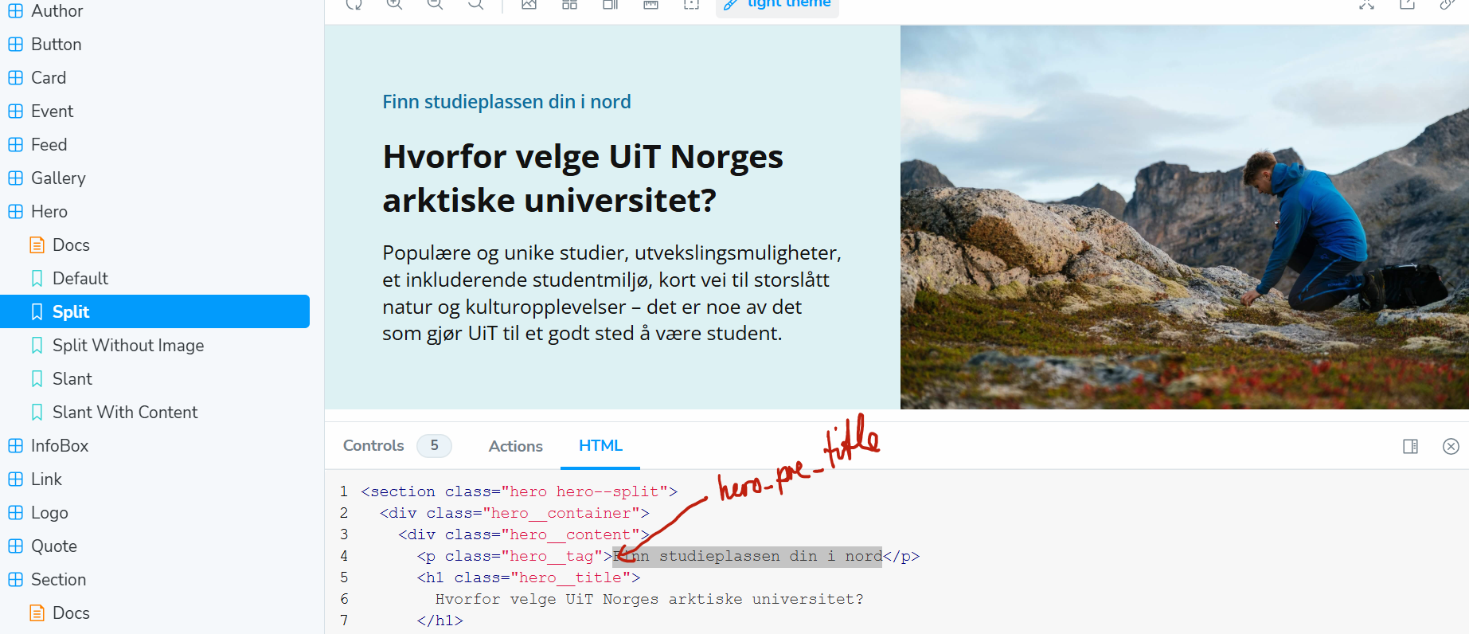

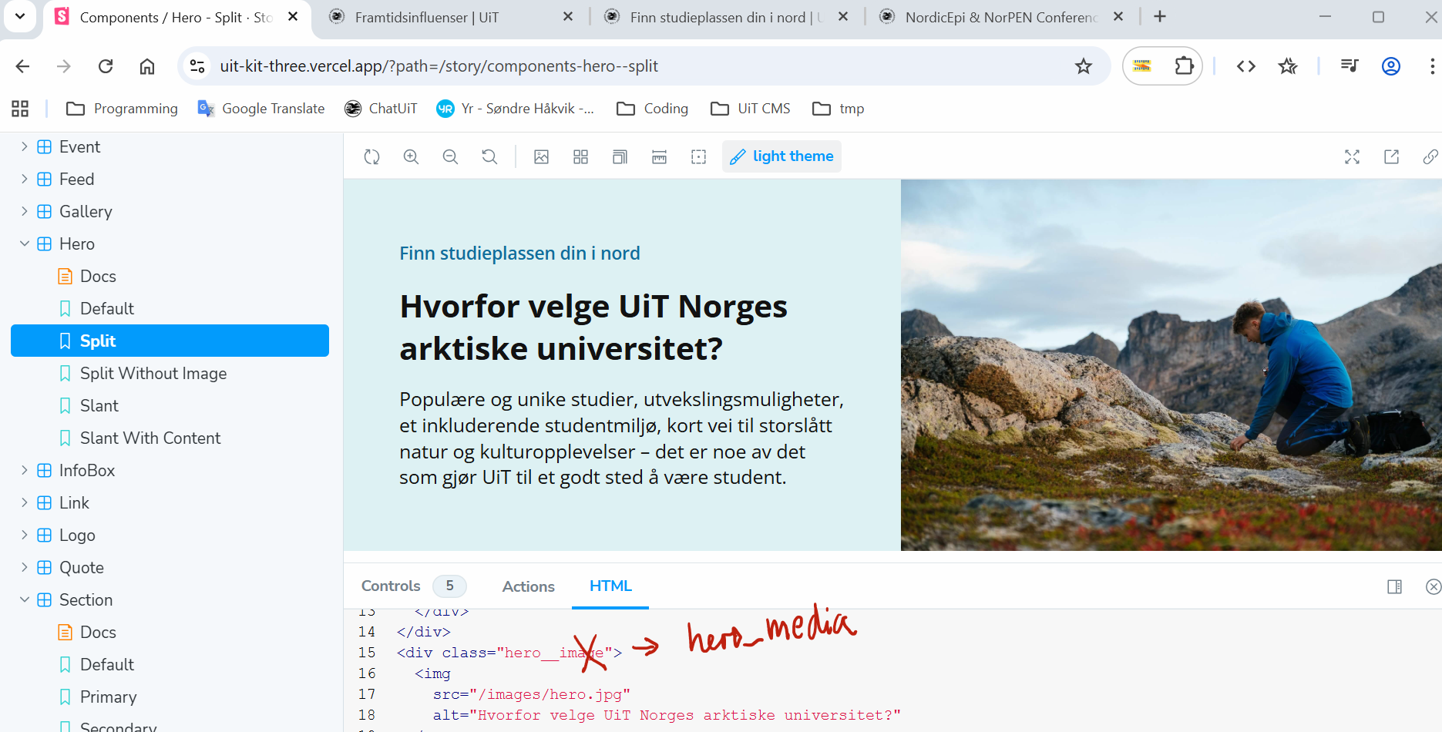

Font Awsome

1. Hero

## 2. Feeds eller Tiles (4 nyheter/ artikler)

Tile: variant = vertical Feed: variant = feed (defauit)

3. Link-seksjon med innsalg -> CTA

Hvordan skal denne «få lov til å» se ut?

4. Collage

Video smaller (for å lage html-video)

## Studieprogram (katalog)

* [StudieprogramFields (lagret i Teams)](https://universitetetitromso.sharepoint.com/:x:/r/sites/O365-Nywebplattform/_layouts/15/Doc2.aspx?action=edit&sourcedoc=%7B3baea2eb-4de2-41e4-a410-16b8d811233c%7D&wdOrigin=TEAMS-MAGLEV.teamsSdk_ns.rwc&wdExp=TEAMS-TREATMENT&wdhostclicktime=1760346551390&web=1)

### Eksempel B-BY (Bygg, ingeniør – bachelor)

Sted:

Hva er sted per definisjon? Studiested, Campus, Ansvarlig sted osv.?

* P-STED = «Narvik, Alta, Tromsø”

* P-SPRÅK = «Norsk”
* P-UNDSPRAK = ?

😮

* <https://html-cleaner.com/>
* [Slik jobber du med studieprogramsiden](https://uit.no/ansatte/arbeidsstotteutdanning/studadminsyspros/sub?p_document_id=904862#data-i-fs)
* Drupal har innebygde filtre (må bare konfigureres)

## Studentintervju

* Landinssider
* TikTok
* Kampanjesider
* Samtykkeskjema

### Studieprogram innsalgside

Forslag, skisser (fra bl.a. Los & Co) og nåværende utforming.

* [Los & Co skisse](https://universitetetitromso.sharepoint.com/:b:/r/sites/O365-Studieprogramsidenepuit.no/Shared%20Documents/General/UX-design%20Los/De%20f%C3%B8rste%20skissene%20fra%20Los/Studieprogramsider%20(3).pdf?csf=1&web=1&e=YzNdA1)

*Dagens eksponering  
(Bildet er så stort at det er nødt til å bære hele budskapet om hva vi ønsker å selge!)*

*Test*

* [Studiekatalog > Akvamedisin](https://uit.no/utdanning/program/268952/akvamedisin_-_master)
* [Storybook > HhHero | Split (leveranse fra Los & Co)](https://uit-kit-three.vercel.app/?path=/story/components-hero--split&args=title:Akvamedisin)  
  (NB! Header, heading, title brukes om hverandre…)
* [Nettsider > Arrangement (forslag fra Los & Co)](https://www.figma.com/proto/yDDclJQ7rIFWlQVkDPQFXY/UIT-Nettside-Skisser?node-id=719-2873&t=X44Uu6jmAFRGA7Ia-1&scaling=scale-down-width&content-scaling=fixed)



